Potential hazards the player could encounter:

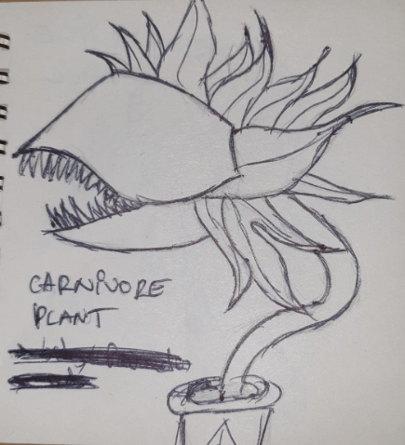

- Carnivore Plant: -can damage the player if hp is high;
-can eat the player if hp is low;

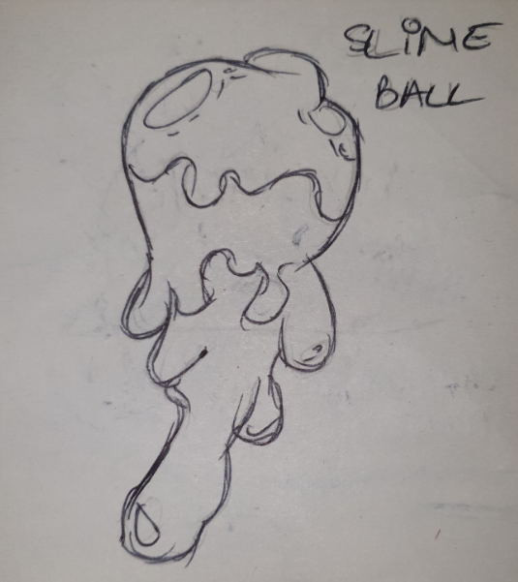

- Slime Ball: - slows down the player;

-falls from the ceiling;

-if the slime ball hits the player directly it deals half
of the hp;
-sometimes rolls from side to side leaving slime on
the ground which slows the player;

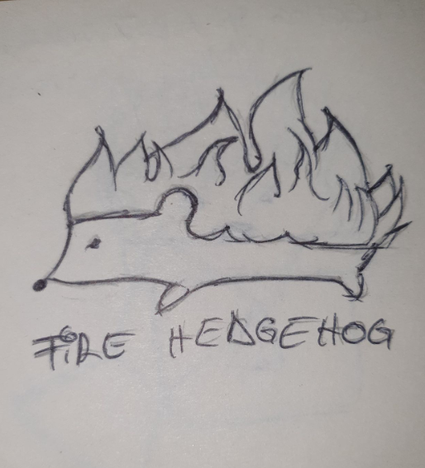
- The fire hedgehog: -shoots fire spikes ;
-can ignite surrounding units;

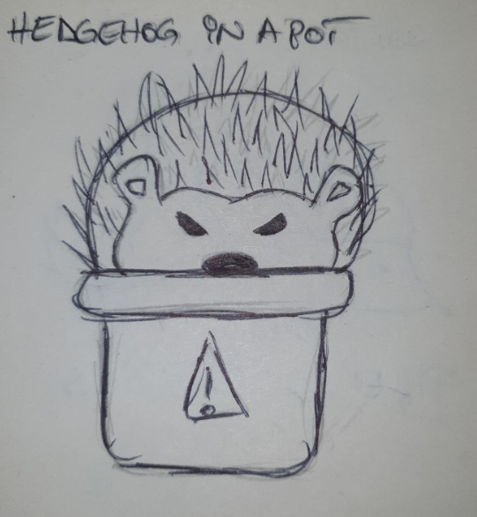

- Hedgehog in a pot: -if the player jumps/steps on
a hedgehog in a pot will get stung
and hp will drop for 5 seconds after
impact;

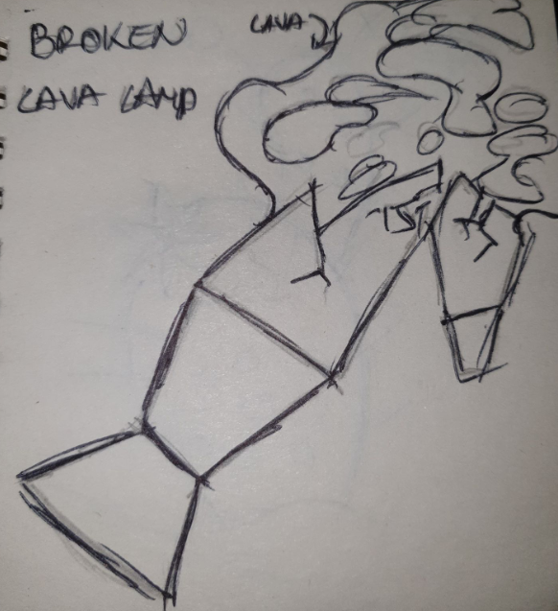

- Broken Lava lamp: -the lava can burn wood platforms;
-hp goes to 0 if player touches lava;

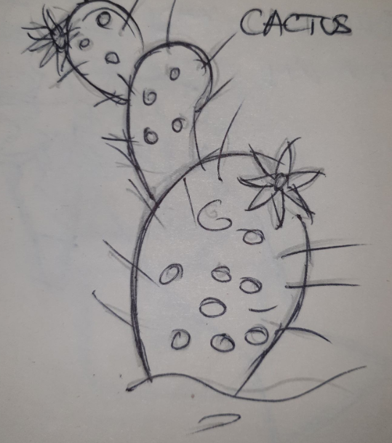
- Cactus : -shoots spikes;
-can spray poison from the flowers;

